Create file directory -> Desktop -> CIProject -> Vagrant Setup. Right click Windows Explorer and select Git Bash Here

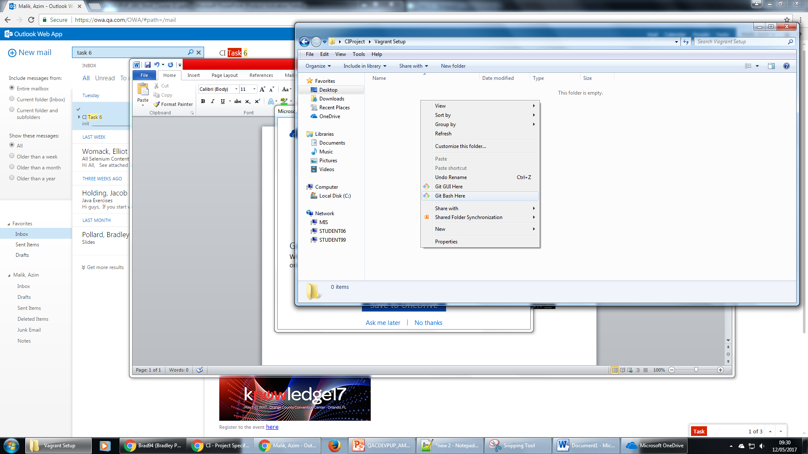

Initialise a new vagrant repository

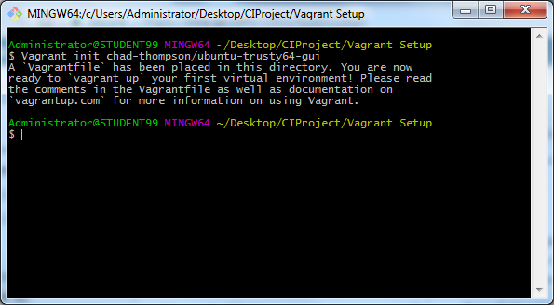

A Vagrant file has been added to the directory. Updated with only the relevant credentials below :

config.vm.box;

config.vm.network;

config.vm.provision;

config.vm.provider;

config.vm.synced_folder;

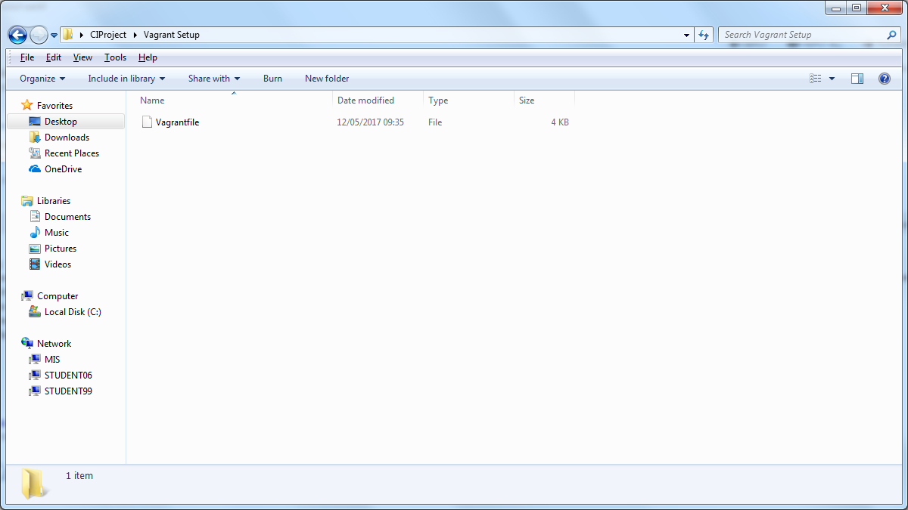

Create bootstrap.sh file

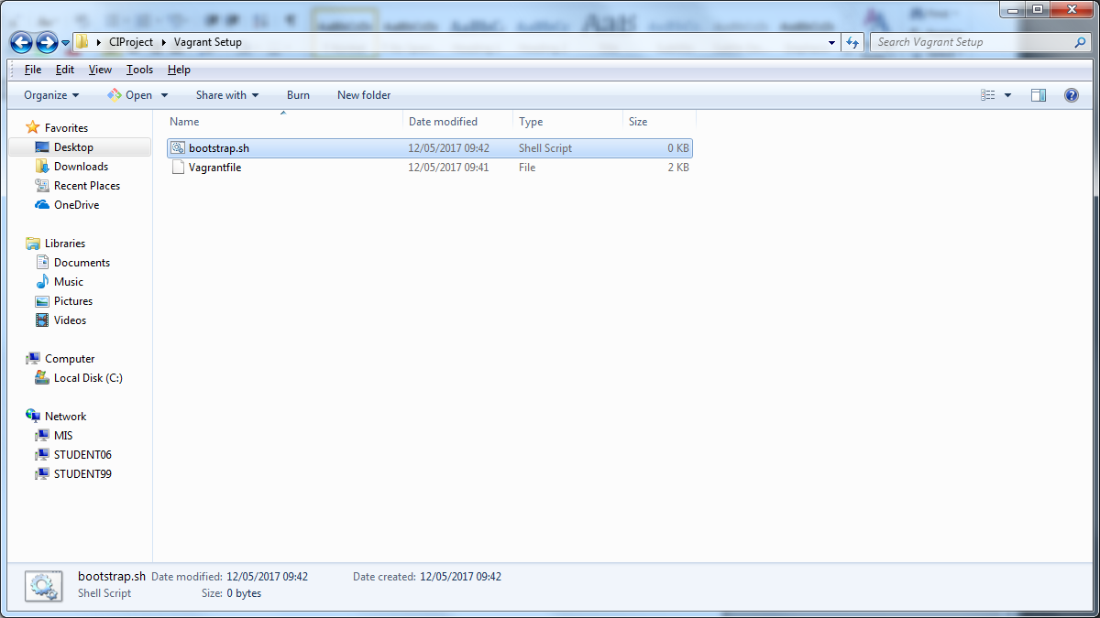

Create shared folder

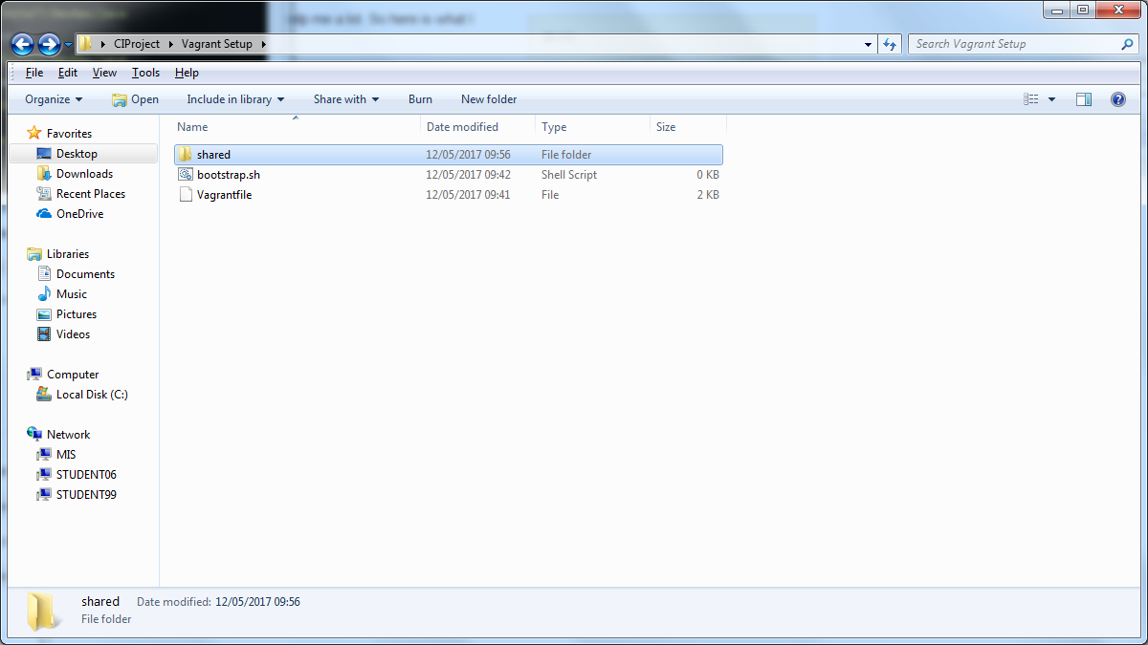

Copy files from LocalIInstall to shared folder

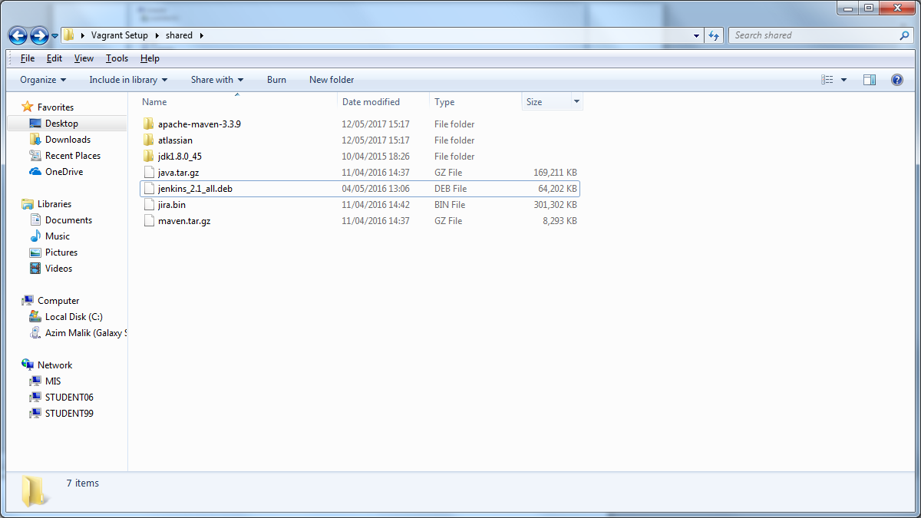

Run vagrant up

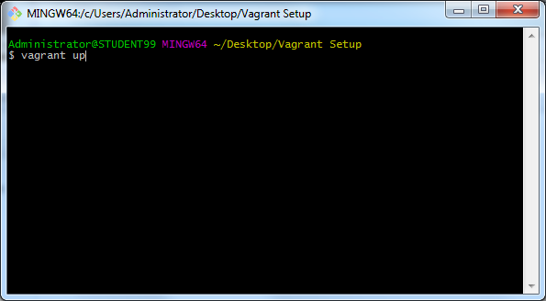

Virtual machine is created

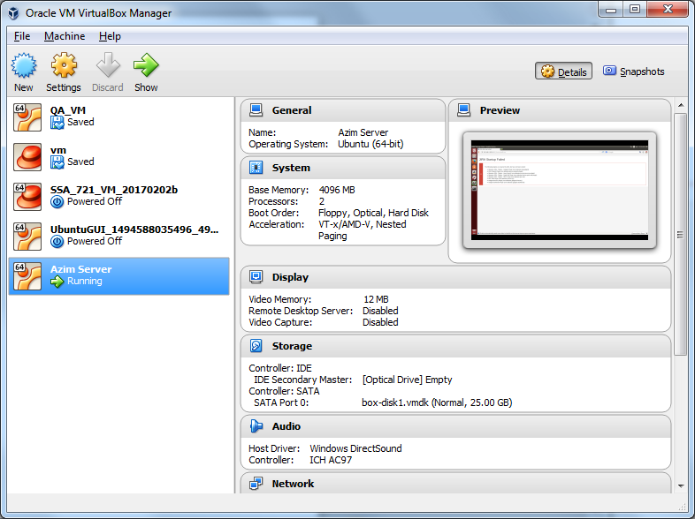

Boostrap.sh file is run and shared files are located and extracted.

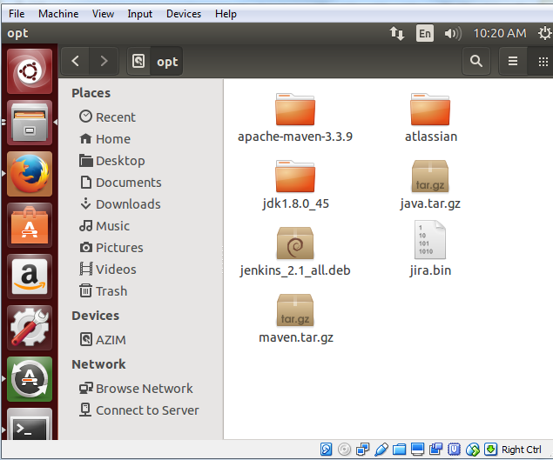

Installation of the relevant files are successfully installed

